**Art - Year 2**

Autumn Term – Leonardo Da Vinci

**DT links**

Use tools e.g. scissors and a hole punch, safely   
(Y1)

With help, measure, mark, cut and shape a range of materials (Y1)

**Art links**

Use a sketchbook to gather and collect artwork (Y1)

Begin to explore the use of line, shape and colour (Y1)

Use a variety of tools Inc. pencils, rubbers, crayons, pastels, felt-tips, charcoal, ballpoints, chalk and other dry material (Y1)

Explore the differences and similarities within the work or artists, craftspeople and designers in different times and cultures (Y1)

**English Texts**

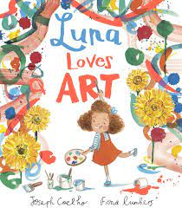



Experiences