**Design Technology - Year 2**

Spring Term – Making hand puppets

**DT links**

Join different materials and explore different textures (REC)

Parts of a structure can be joined in different ways (Y1)

Working with tools, equipment materials ad components to make quality products (Y1)

**Science links**

Objects are made from materials such as wood, fabric, glass, metal, cardboard, plastic or clay. (Y1)

**Art links**  
  
Use a wide variety of media, including photocopied material, fabric, plastic, tissue, magazines, crepe paper etc. (Y1)

**History links**

A plastic is a kind of material that is made by people and can be formed into almost any shape. (Y1)

**English Texts**

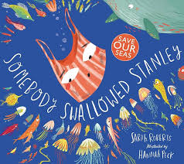



Experiences