**Design Technology - Year 5**

Autumn Term – Bread

**DT links**

Pitta bread is a healthy alternative to sliced bread with more vitamins, minerals a fibre (Y3)

Demonstrate hygienic food preparation and storage (Y3)

**Maths links**

Measurement: Mass, volume and length (Y4)

**English links:**

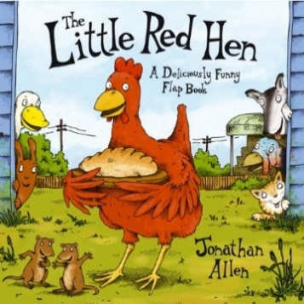



Healthy Lifestyles