Design Technology - Year 6
Summer Term – Culture and seasonality

DT links

Ingredients such as seeds, raisons, garlic, herbs etc can be included for taste (Y5)

A balanced diet consists of all the different groups but too much of some would be unhealthy (Y3)

Fajitas are a Mexican dish consisting of ingredients encased in a tortilla wrap (Y3)

Demonstrate hygienic food preparation and storage (Y3)

Science links:
Recognise the impact of diet, exercise, drugs and lifestyle on the way in which their bodies function (Y6)

DT links

Examples of biomes include rainforests, forests, oceans, grasslands, savannahs, polar regions and deserts (Y3)

The equator is the closest part to the sun (Y3)

Human geography is the branch of geography that is associated and deals with humans and their relationship with communities, cultures and economies (Y5)

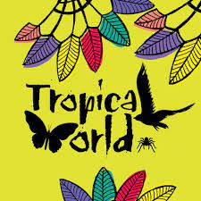
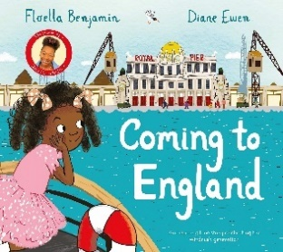
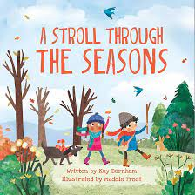
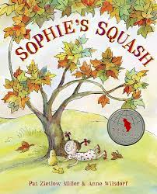

English links:
Healthy lifestyles

