Design Technology - Year 3
Autumn Term – Levers and linkages

Science links
Identify and compare the suitability of a variety of everyday materials including wood, metal, plastic, glass brick, rock, paper are cardboard for particular uses. (Y2)
DT links

Sliders and levers unit (Y1)

Parts of a structure can be joined in different ways (Y1)
We can join materials together using staples, safety pins, glue, tape, stitching (running stitch) (Y2)

A wheel spins around an axle in a rotary motion (round and round) (Y2)

Art links

Understand the basic use of a sketchbook and work our ideas for drawings (Y2)

English Texts
History links
Plastics can be made into almost any shape by heating them at a high temperature (Y1)

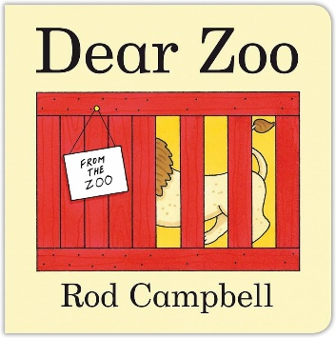


Experiences

