**Geography - Year 3**

Summer Term – Comparing a UK city with a European city

**English Texts**

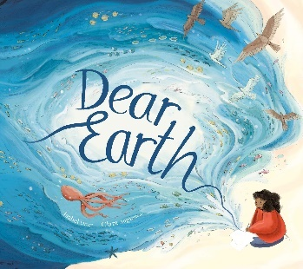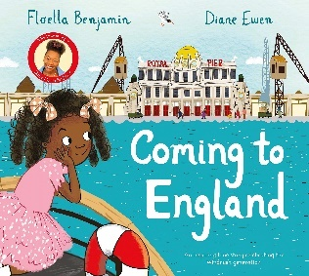

**Geography links**

Investigate their surroundings (Y1)

Use relative vocabulary (e.g. smaller/bigger, like/dislike) (Y1)

The seven continents are Antarctica, North America, South America, Europe, Asia, Australia and Africa (Y2)

In some countries it is nearly always hot (Y2)

Make appropriate observations about why things happen (Y2)

**History links:**

They know and recount episodes from stories about the past (Y1)

Compare pictures or photographs of people or events from the past (Y2)



Experiences