**Geography - Year 6**

Spring Term – Canals, reservoirs, rivers and the water cycle

**Geography links:**

Use index and contents page within atlases (Y5)

Select a map for a specific purpose (Y5)

Draw a plan view map with some accuracy

Collect and record evidence unaided (Y5)

**Science links:**

Everything falls into one of three categories: solids, liquids and gases (Y4)

Materials can change from one state to another to another trough freezing and melting (Y4)

The water cycle converts water into three different states; liquid, solid (ice) and gas (vapour) (Y4)

Vapour that has turned into liquid can be released by clouds in the form of rain or snow (Y4)

****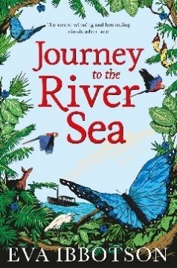**English links:**

Sustainable development goals