**Geography - Year 2**

Spring Term – Local study

**English Texts**

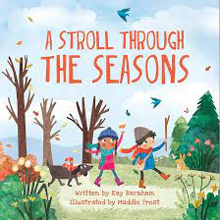  


**Geography links**

The official name of the UK is “The United Kingdom of Great Britain and Northern Ireland.” (Y1)

The UK is made up of four countries which are England, Ireland, Scotland and Wales (Y1)

There are four different capital cities in the UK which are: London – the capital of England, Edinburgh – the capital of Scotland, Cardiff – the capital of Wales and Belfast – the capital of Northern Ireland (Y1)

History links

Queen Victoria’s reign is known as the Victorian era (Y1)



Maths links

Position and direction (Y1)

Heritage