**Geography - Year 3**

Autumn Term – Effects of human activities on the UK landscape

**English Texts**

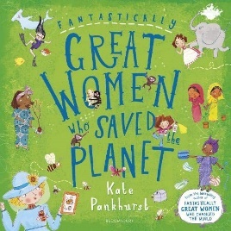  
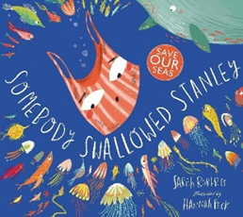

**Geography links**

Make observations about where things are e.g. within school, or local area (Y1)

Investigate their surroundings (Y1)

Locate and name on the UK map major features e.g. London, River Thames, home location, seas (Y2)

Make appropriate observations about why things happen (Y2)

**History links:**

Plastics are very useful but they can also cause many problems for the environment if they end up in the oceans (Y1)

Recognise why people did things, why events happened and what happened as a result (Y2)

Identify differences between ways of life at different times (Y2)



Sustainable development goals