Year 4 Homework
Please complete a minimum of one task per half term by Wednesday 14th October 2025.
You may present your work in any way that you wish. We look forward to seeing some of your amazing creations! Have fun!
Task Options
SCIENCE: Make a chart to show different uses of solids, liquids and gasses in your home. | PE : Make a list of instructions showing how to play hockey.
History: Can you research and compare the life of a Victorian child to the life of a child today. | SCIENCE: Make a model of the water cycle.
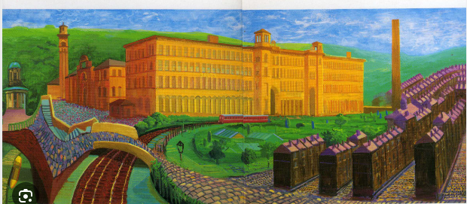  ART: This is David Hockney’s picture of Saltaire - you can make a model of it or do your own | Geography - Can you create a map of Saltaire, showing Salts mill, the hospital, church and Roberts park.

