Year 2 Homework
Please complete a minimum of one task per half term. To be returned by Friday 30th of January.
You may present your work in any way that you wish. We look forward to seeing some of your amazing creations! Have fun!
Task Options
Create your own puppet for a small pantomime. You can choose any character you like.  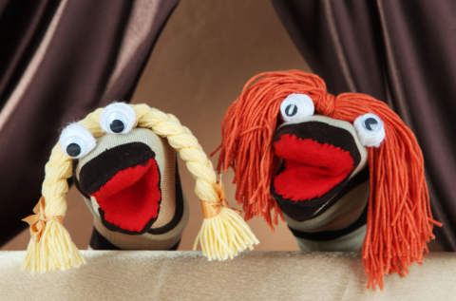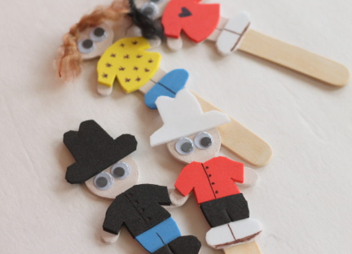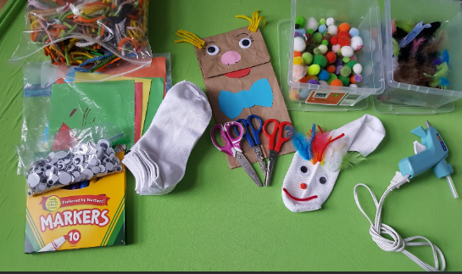 | Create your own puppet theatre or a stage.  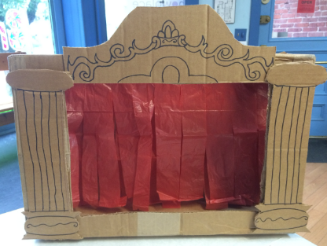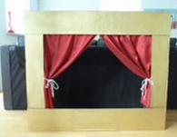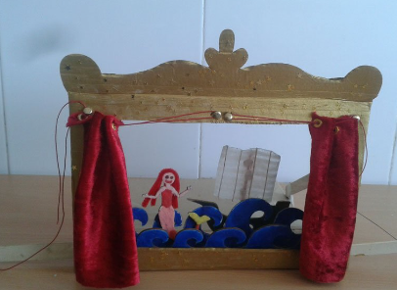
Write down a story based in the city (It could even be Bradford!)  Think about your characters, setting and the problem in the story.  Please remember to use capital letters, full stops, conjunctions, adjectives and your most gorgeous handwriting😊 | Draw a map showing your route to school.  Don’t forget to include buildings that you see on the way to school.  Make a map key explaining symbols on your map.  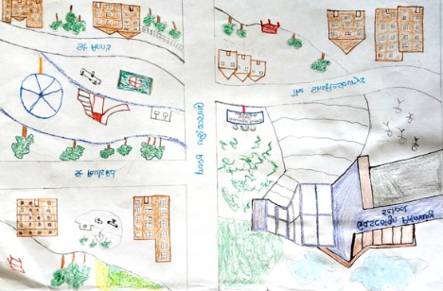
If you need any resources please ask.

