Please complete a minimum of two tasks this half term. You may present your work in any way that you wish. We look forward to seeing some of your amazing creations below are some ideas of tasks you could have a go at. Have fun! If you need any resources or please just ask.
Try these websites to give you some ideas: https://kids.britannica.com/kids/article/Egypt/345682 https://www.bbc.co.uk/bitesize/articles/z6x2382 .
Task Ideas
Geography:  Design a tourist information leaflet to encourage tourists to visit modern day Egypt. Think about the top 5 reasons people should go there for a holiday. Remember to include pictures,photographs and drawing. Make it bright and beautiful so that people are excited to go there.  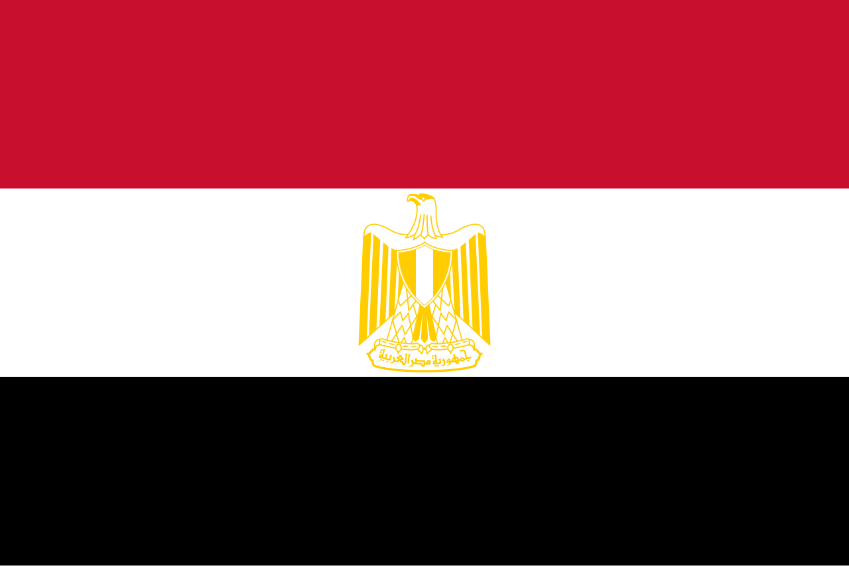 | Literacy:  Create a word search or crossword about ancient Egypt. Make your clues as tricky as you can!  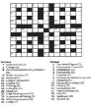
Art/DT:  Build your own 3D model of an Egyptian Pyramid, be as creative as possible.. Think about what materials and construction method is best suited to creating your model.  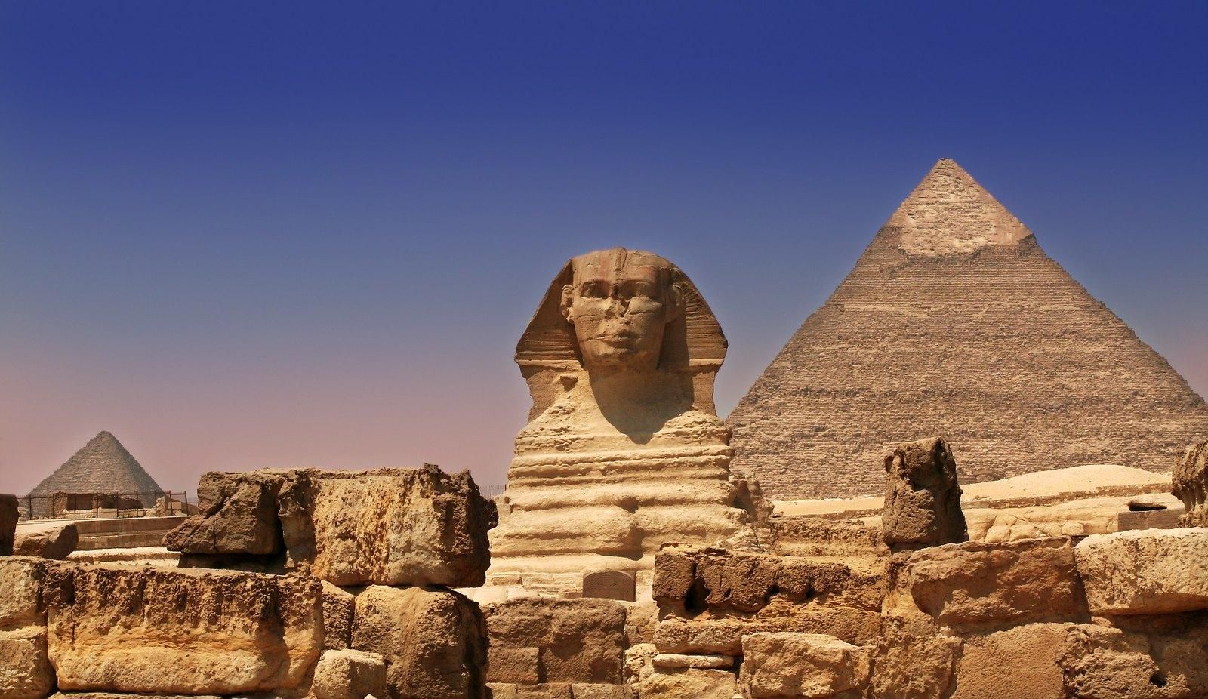 | 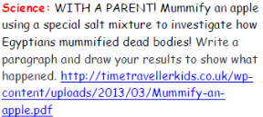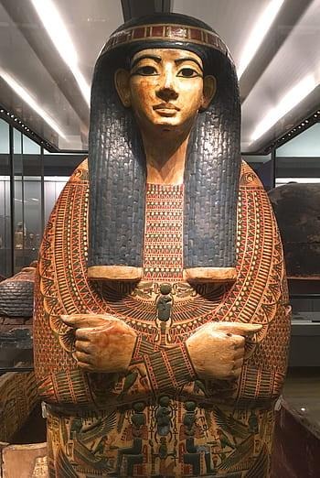
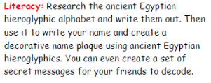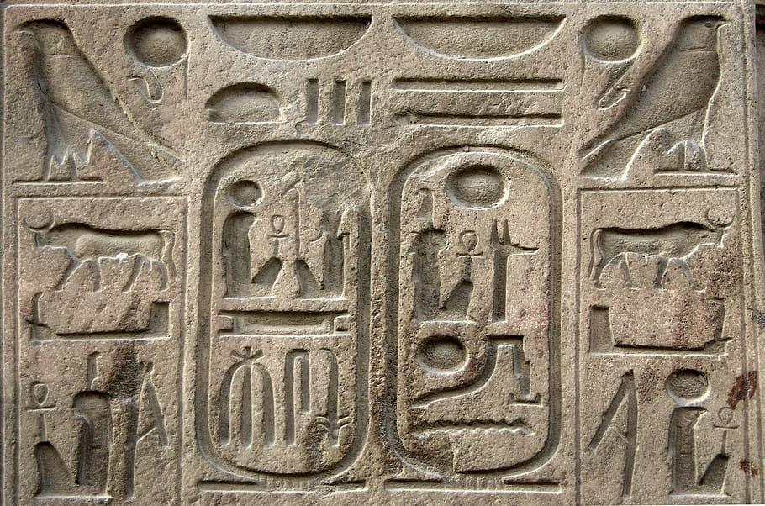 | 