Year 2 Homework
Please complete a minimum of one task per half term. To be returned by Friday 20th of March 2026.
You may present your work in any way that you wish. We look forward to seeing some of your amazing creations! Have fun!
Task Options
Sketch, paint or draw one of the famous buildings from Bradford.  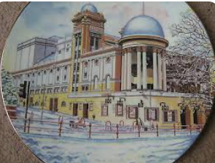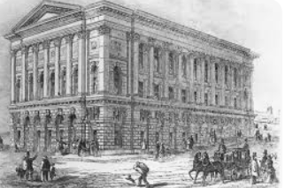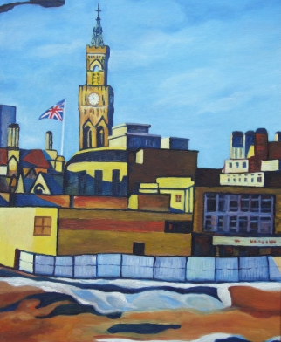 | Create your own puppet theatre or a stage.  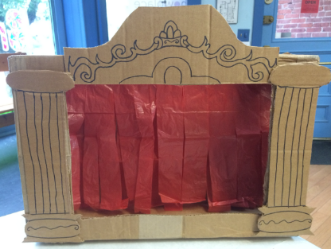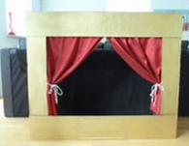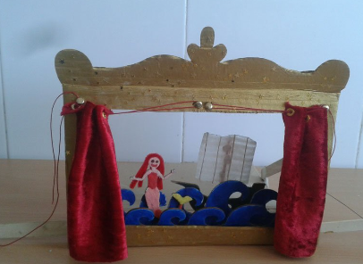
Make a display of fractions. Show halves, quarters and thirds.  Use any objects you want.  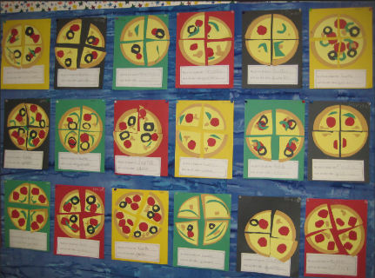 | Draw a map showing your route to school.  Don’t forget to include buildings that you see on the way to school.  Make a map key explaining symbols on your map.  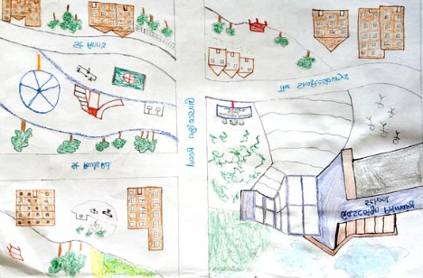
If you need any resources please ask.

