 Year 4 Homework Spring 2
Please complete a minimum of one task per half term by the 25th March 2026.
You may present your work in any way that you wish. We look forward to seeing some of your amazing creations! Have fun!
Task Options
Can you introduce yourself and your family to a friend in Spanish. Record yourself speaking if you wish or write down the conversation in Spanish!   | Complete a diary for a week to show your balanced diet.  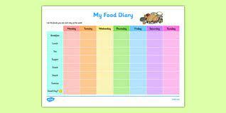
Create a model of your favourite animal food chain or habitat.  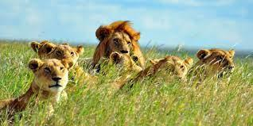 | Research why forgiveness is important to Christians.  
Create a timeline of the events of the Great fire of London.  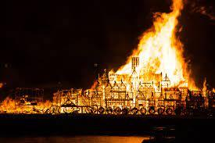 | Research how fire stations and engines changed after the great fire of London.  

