Please complete a minimum of two tasks this half term. You may present your work in any way that you wish. We look forward to seeing some of your amazing creations below are some ideas of tasks you could have a go at. Have fun! If you need any resources or please just ask. REMEMBER IT IS ONLY A SHORT TERM!!!
Try these websites to give you some ideas: https://kids.britannica.com/kids/article/Egypt/345682 https://www.bbc.co.uk/bitesize/articles/z6x2382 .
Task Ideas
History::  Write a transcript for your own humorous sketch that could be included in The Awesome Egyptians on Horrible Histories.  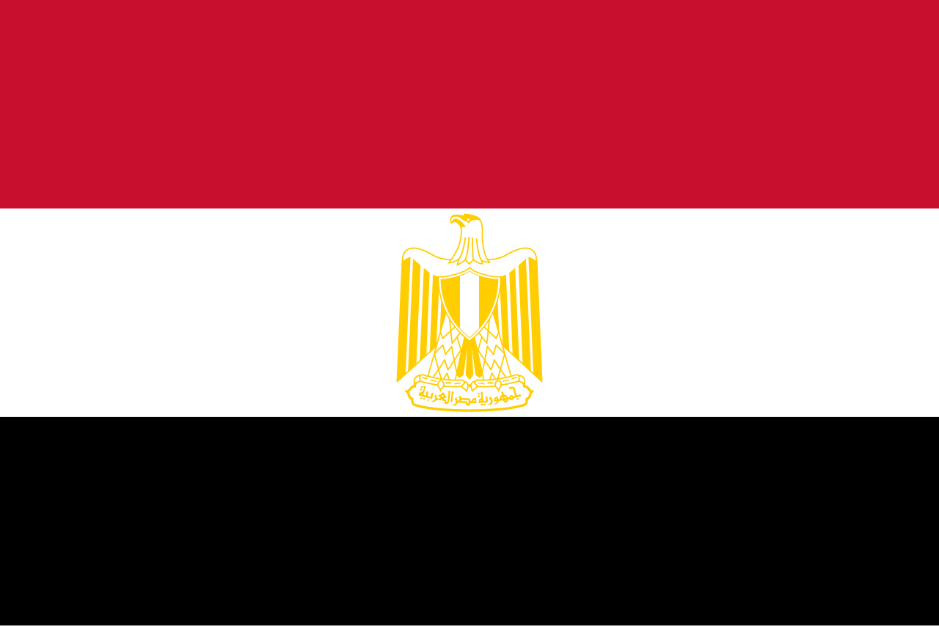 | Literacy: Create a fact file about ancient Egypt.  Think about the river Nile, the Pyramids, the gods, food and drink, their clothing and the houses.
Art/DT:  Build your own 3D model of an Egyptian Pyramid, be as creative as possible.. Think about what materials and construction method is best suited to creating your model.  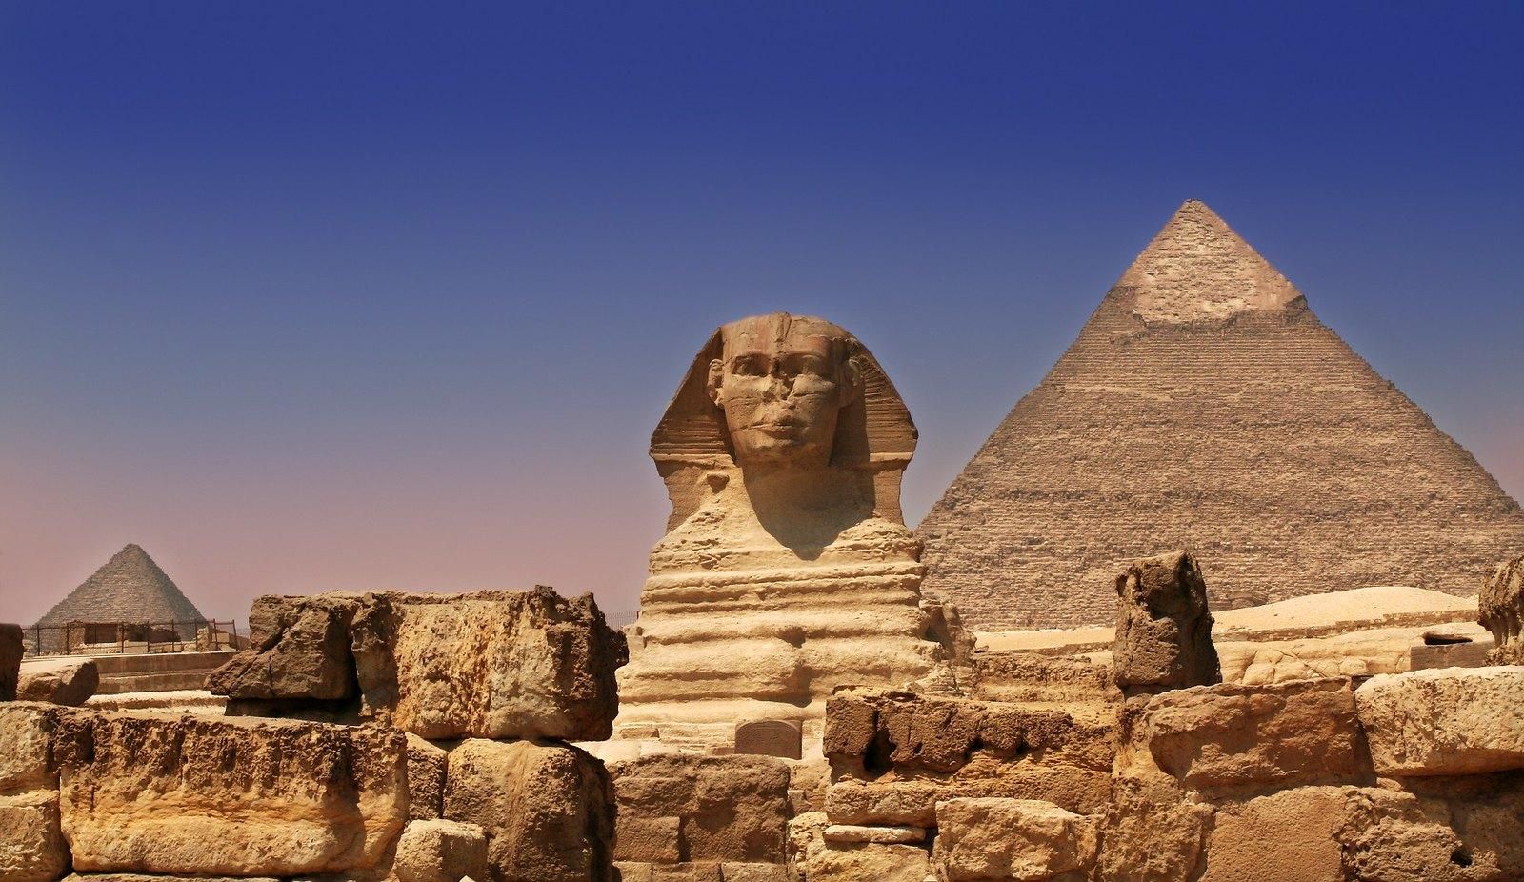 | 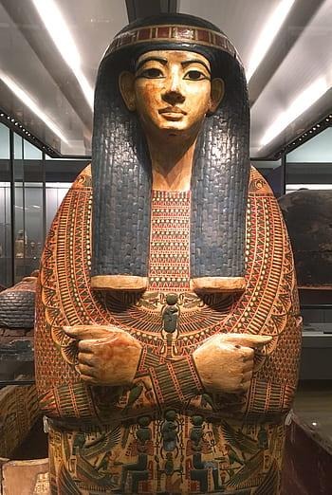  Art and DT: Create your own tomb or coffin for a mummy.  Remember they are decorated with a picture of the person and show off their wealth.
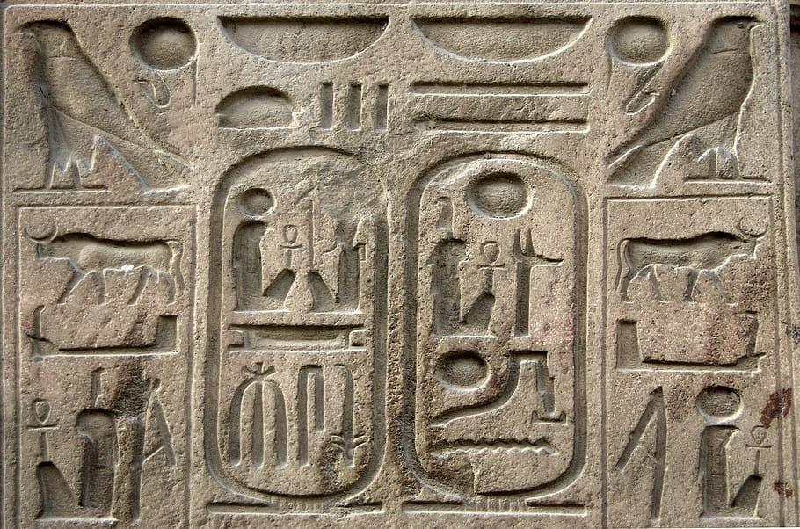Create your own maths word problems relating to the Egyptians. | 