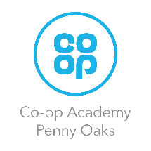
Year 5 Homework

Please complete a minimum of two tasks per half term. To be returned by Friday 22nd May. We look forward to seeing some of your amazing creations! Have fun!
Please encourage your child to read each night using MyOn. There are maths tasks set on Prodigy- this will help your child’s maths learning as I will set them targeted activities.
As much as possible practise:
timestables - timestables.co.uk
spellings: Spellingframe.co.uk
Task Options
Draw a picture of a train from the Industrial Age and explain the history of trains and how they developed during the Industrial Age. | Make a collage of the changes that happened to the lives of common people between the 18th century and the 21st century.
Rate 10 inventions of the Industrial Revolution and rank their importance. Explain why you ranked them in that order. | Write a diary entry of how you would feel if you worked in a factory/mine during the industrial revolution.
Create a menu that rich people would have eaten during the Victorian times and one that poor people would have eaten. Compare the two. What are the similarities and differences? | Draw or trace a world map. Mark the countries that were part of the British Empire during the Victorian Era/Industrial Revolution.

