Year 1 Homework
Please complete a minimum of two task per half term. To be returned by 13th May 2026. You may present your work in any way that you wish. We look forward to seeing some of your amazing creations! Have fun!
Task Options
Create your own Rangoli design on a piece of cards using glue and different colored dried lentils, pulses, or dyed rice.  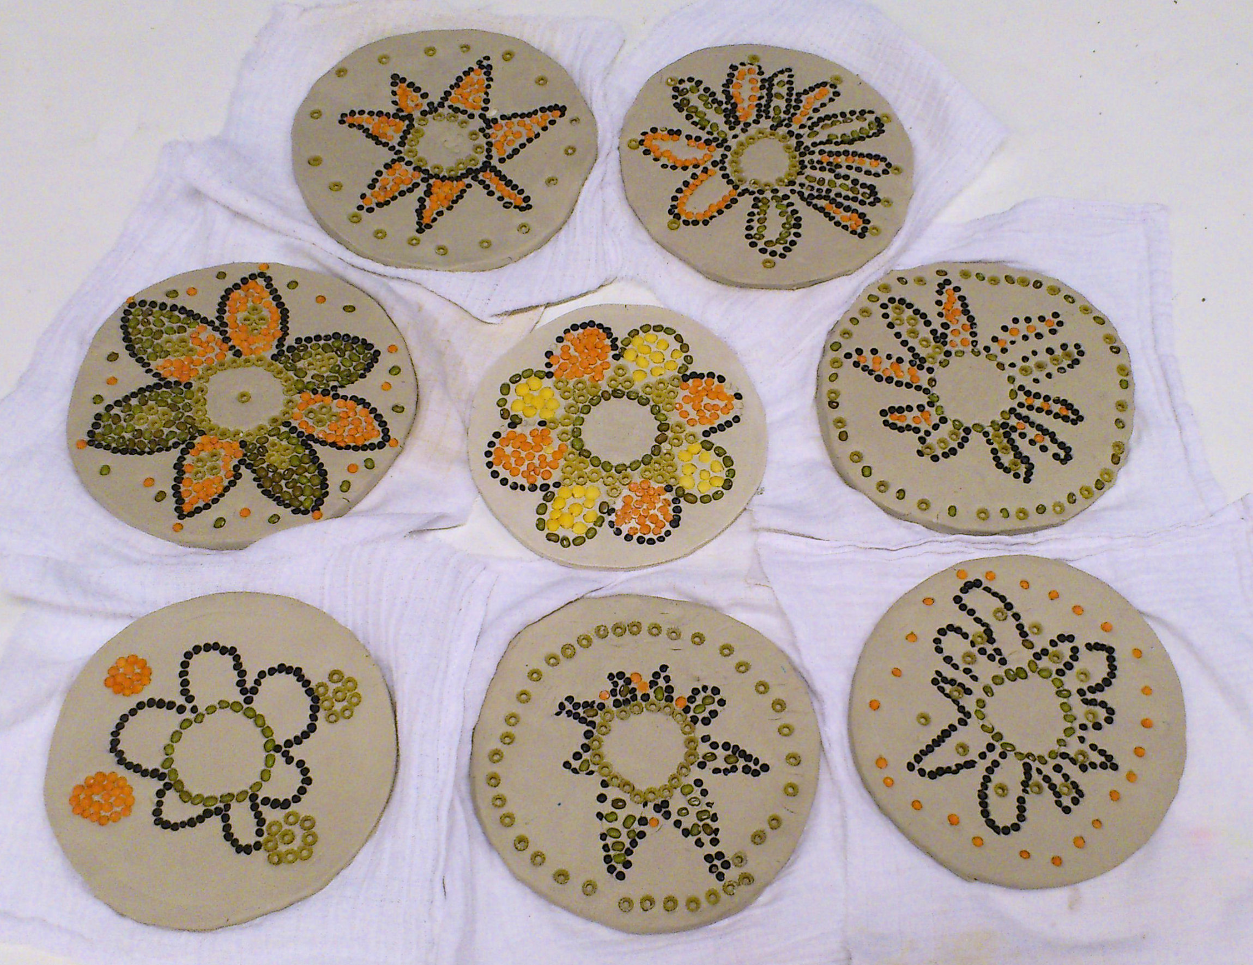 | Design and make your own peacock.  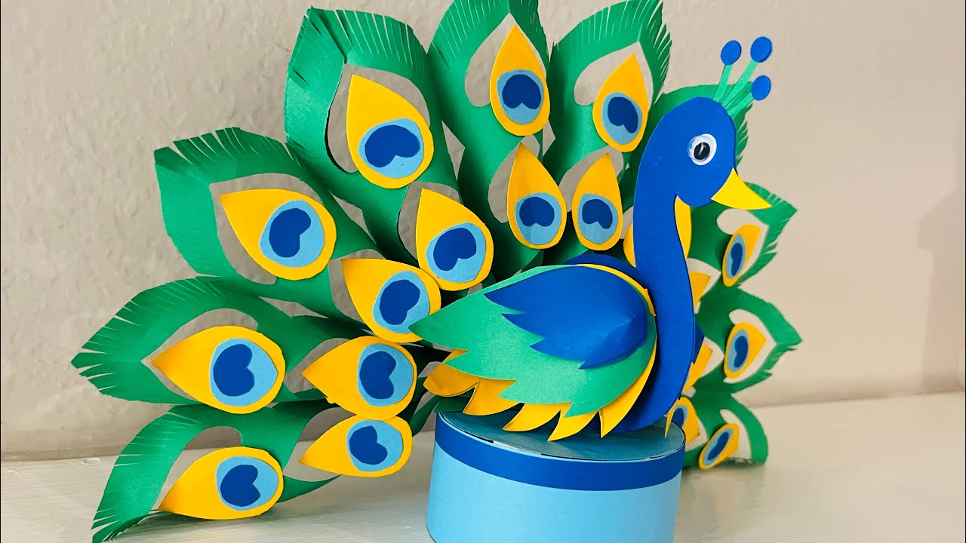
Create a famous landmark in India.  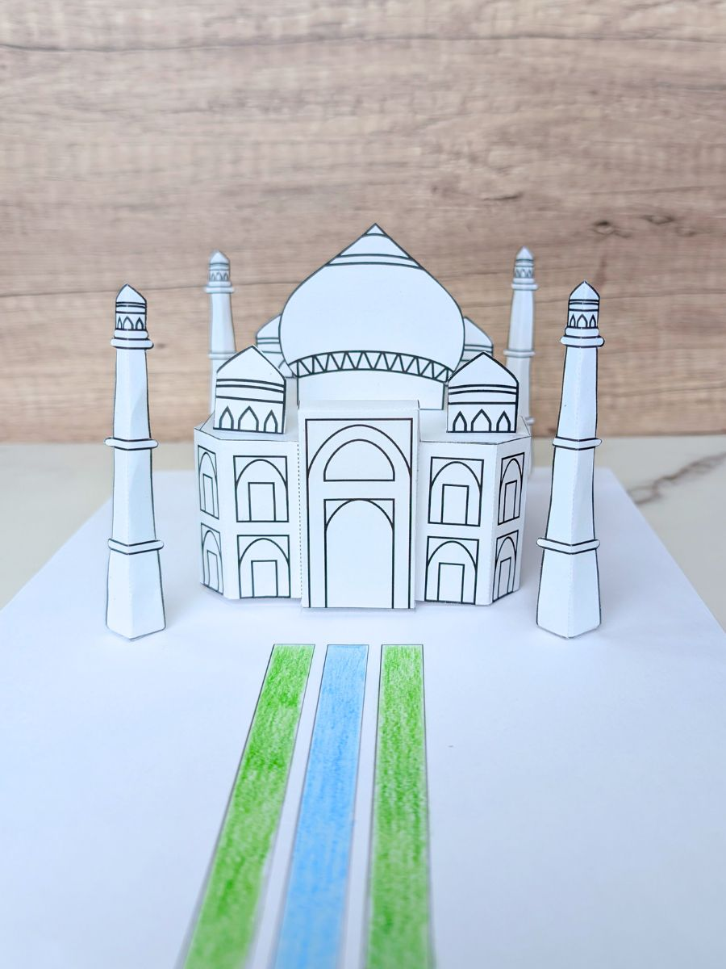 | Draw and label the Indian flag.  