**History - Year 5**

Spring Term – Monarchs

**History links**

Queen Victoria ruled for almost 64 years (Y1)

Victoria would become the longest reigning British monarch and Queen of the biggest empire in history (Y1)

Queen Victoria’s reign is known as the Victorian ea (Y1)

Compare pictures or photographs of people or events in the past (Y2)

Compare with our life today (Y3)

Distinguish between different sources – compare different versions of the same story (Y3)

Choose relevant material to present a picture of one aspect of life in time past (Y4)

Recall, select and organise historical information (Y4)

Place events from period studies on a time line (Y4)

Understand complex term e.g. BC/AD (Y4)

**Geography links**

The UK is made up of four countries which are England, Ireland, Scotland and Wales (Y1)

King Charles III lives in London and is the king of the UK (Y1)

Use non-fiction books, stories, atlases, pictures, photographs, and internet as sources of information (Y3)

Analyse evidence and draw conclusions e.g. make comparisons between locations, photographs, pictures and maps (Y4)

**English links:**

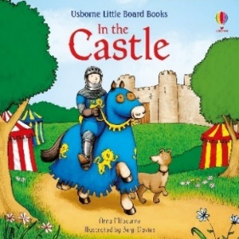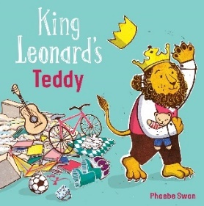



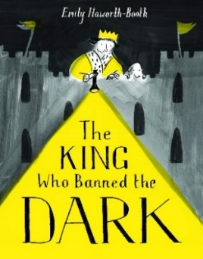

Heritage