Year 2 Homework
Please complete a minimum of one task per half term. To be returned by Monday 19th May 2025.
You may present your work in any way that you wish. We look forward to seeing some of your amazing creations! Have fun!
Task Options
Create a seaside shoebox habitat. Include animals and plants.  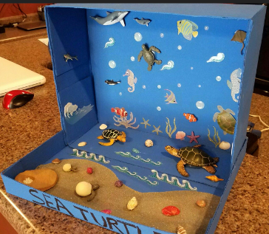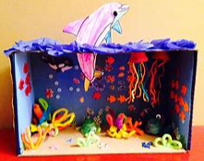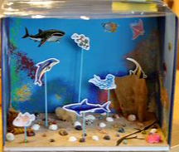 | Create a fact file about whales. Include as much information as you are able to find.  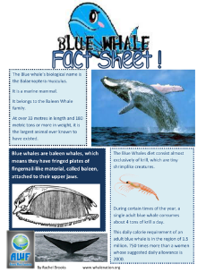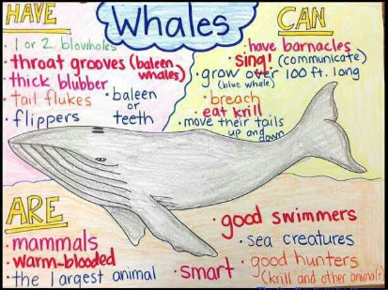
Write a story set at the seaside. Your characters can be sea creatures.  In your writing, make sure you include:  -Capital letters and full stops  -Gorgeous handwriting, adjectives to describe and contractions  -Belonging apostrophes, questions  -Check if your sentences make sense | Draw a picture of the seaside. Identify and label its physical and human features.  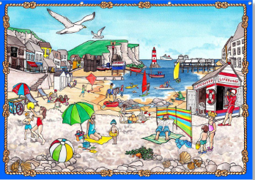
If you need any resources please ask.

