Year 2 Homework
Please complete a minimum of one task per half term. To be returned by Monday 7th of October.
You may present your work in any way that you wish. We look forward to seeing some of your amazing creations! Have fun!
Task Options
Make a 3D model of the Wright Flyer or an old-fashioned plane. Try to use recycled materials for this project. Label parts of your aeroplane.  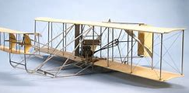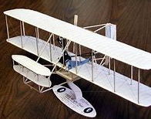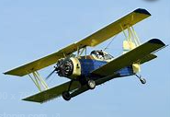 | Write an adventure story. Include interesting characters, capital letters, full stops and neat handwriting.  Could your main character be a pilot?
Create an exercise routine for yourself. Choose few exercises and describe them.  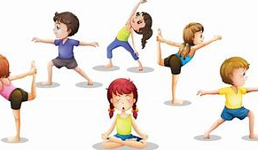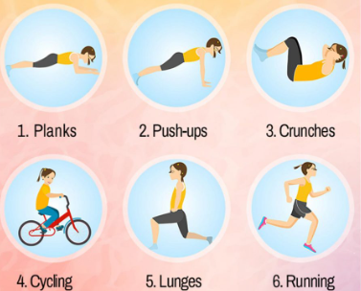 | Make a 2-digit number for example 29 and show it in as many ways as you can. Be creative and use different objects to represent tens and ones.  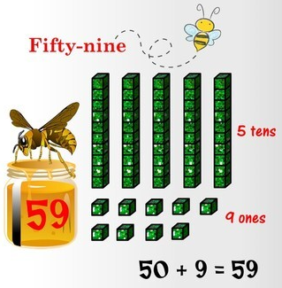
If you need any resources please ask.

