Task Options
SCIENCE: design an accessory that would help car drivers see you in the dark. Which materials would you use? You could even have a go at making it! | 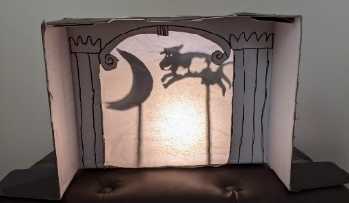  SCIENCE: Build a shadow puppet theatre
HISTORY: Make a Spartan helmet or design a shield  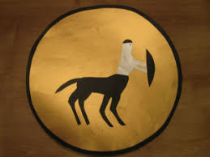  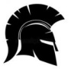 | HISTORY: Make a poster all about the ancient Greeks. Research what they ate and wore and did for work.
RE: Create a fact file all about the River Ganges | ART: design a Greek vase which shows your favourite story

