Year 2 Homework
Please complete a minimum of one task per half term. To be returned by Monday 7th July 2025.
You may present your work in any way that you wish. We look forward to seeing some of your amazing creations! Have fun!
Task Options
Design and make your own pier or a beach hut using lolly pop sticks or twigs.  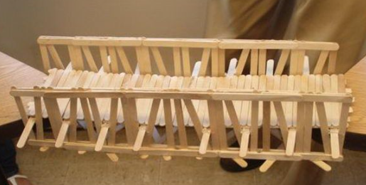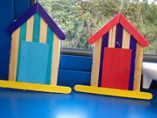 | Using recycling materials like plastic bottles or cups, lids, egg boxes, bubble wrap many others, design and make a sea turtle shell.  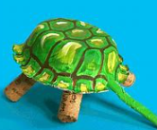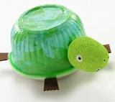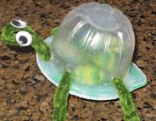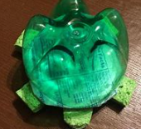
Do some research on David Attenborough. Fid out who he is and why he is such a significant personality.  Create a WANTED letter about sir David Attenborough.  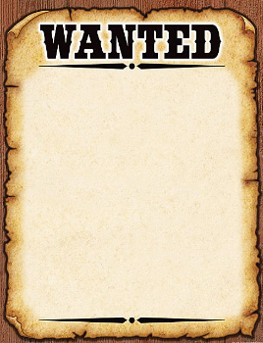 | Make a leaflet about any sea animal and its habitat.  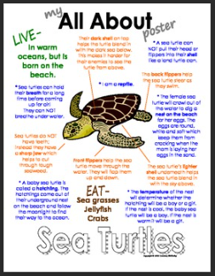
If you need any resources please ask.

