**Key Vocabulary:**

Coastline - area where the sea and land meet

Sculpture - art in 3D

Pastels - a stick made from pure powdered pigment mixed together

Mosaic - a pattern or picture created by putting together small pieces of stone, pottery, glass, tile or paper

Nature - everything in it that's not made by people

Tie-dye - method of dyeing in which patterns are produced in the fabric by gathering together many small portions of material and tying them tightly with string before immersing the cloth in the dyebath.

**Curriculum pathway:**

**Art Year 2**

**Summer Term – The Great British Seaside**

**Ann Steer - Nature sculptures**

**Seascapes**

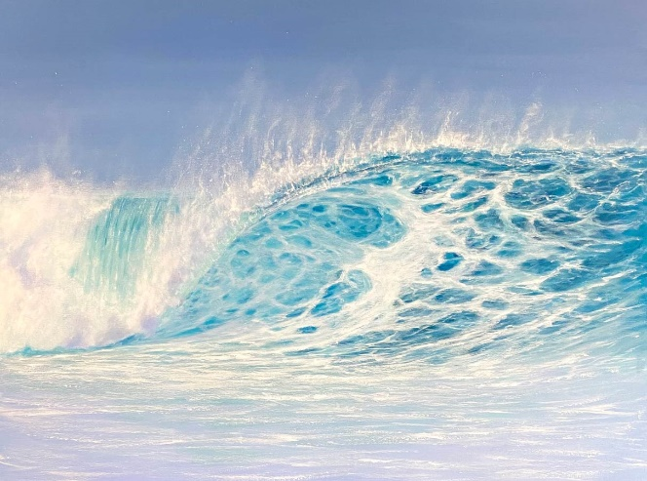

**Key Facts:**

A nature sculpture is a sculpture created with natural resources like sticks, pebbles, shells, leaves etc.

Ann is a professional artist best known for her paintings of the ocean. The ocean has remained her constant inspiration, the rolling of the waves, glistening and reflections in the sand.

The process of tie-dye consists of folding, twisting, pleating, or crumpling fabric or a garment, before binding with string or rubber bands, followed by the application of dye

**Key Questions:**

Who is Ann Steer?

What are nature sculptures?