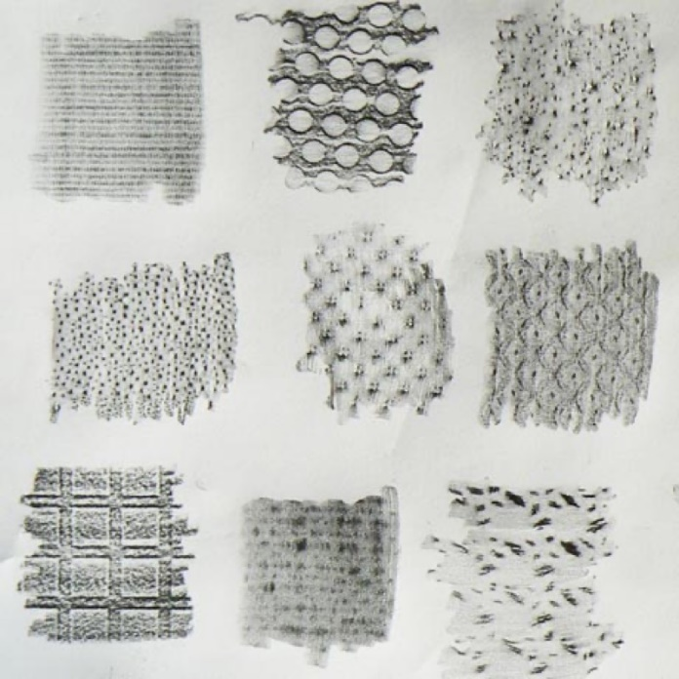

**Key Vocabulary:**

Print - The transfer of text or designs to paper.

Rubbings - An impression of a design on brass or stone, made by rubbing on paper laid over it with coloured wax or pencil

**Art Year 1**

**Autumn Term – Exploring mark making and lines (stamps ink work printing)**

**Curriculum pathway:**

**Key Facts:**

Printing in art is the process of transferring ink or paint from a design onto a surface.

Printmaking is a technique that allows a design to be repeated multiple times.

**Key Questions:**

What is printing?

What is collage

When would we use charcoal?