**Key Vocabulary:**

Washes - a fine layer of colour -usually diluted ink or watercolour - is spread with a brush over a paper evenly

Layering - placing different pieces of paper on top of each other to create a picture

Scumbling - a shading technique achieved by overlapping lots of little circles

Landscape – A picture depicting scenery on land

**Curriculum pathway:**

**Art Year 3**

**Spring Term – Here, There and Everywhere**

**Linda Mackay - Arctic Art**

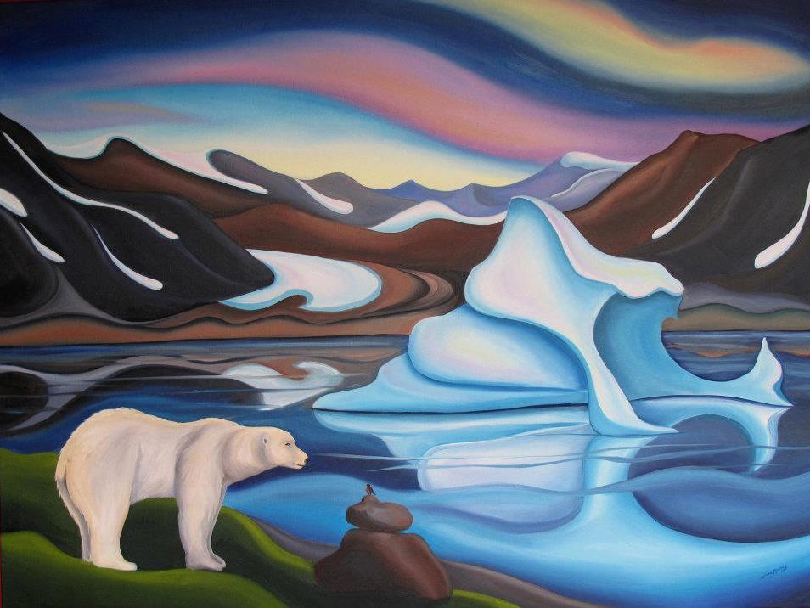

**Key Facts:**

Linda Mackey is a Canadian landscape artist.

**Key Questions:**

Can you describe the style of Linda Mackay’s artwork?

What are the different grades of pencils?