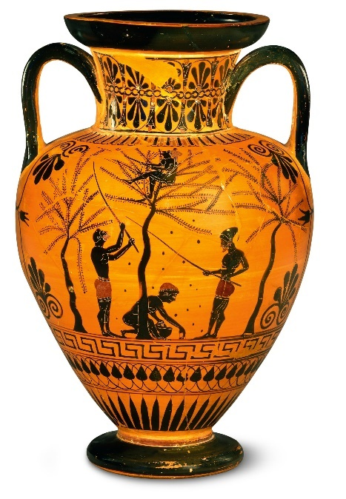

**Key Vocabulary:**

Mould - to knead or work (a material, such as dough or clay) into a desired consistency or shape

Coil – a long form of clay that is rolled into a snake-like form

**Curriculum pathway:**

**Art Year 3**

**Summer Term – Greeks**

**Clay pots**

**Key Questions:**

How did the Ancient Greeks make their pots?

Why were their pots often decorated?

**Key Facts:**

The Ancient Greeks made pots from clay.

Large pots were used for cooking or storing food and small bowls and cups were made for people to eat and drink from.

The decoration on the pots often showed what life was like in Ancient Greece