**Curriculum pathway:**

**Key Vocabulary:**

Hue - another word for colour

Tint - when white is added to create a lighter version of the colour

Abstract art - a form of art with no recognisable subject

**Art Year 4**

**Spring Term – 17th Century Britain**

**National Art Gallery – painting**

**Paul Klee**

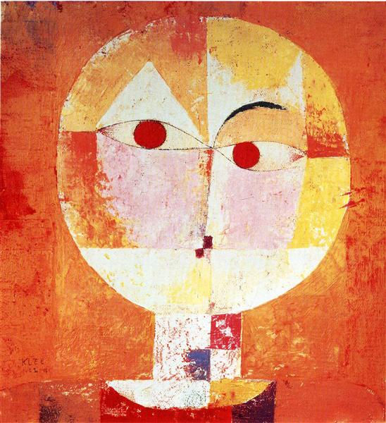

**Key Facts:**

The National Art Gallery is in London and has one of the greatest collection of paintings in the world.

Paul Klee is a Swiss-born painter.

**Key Questions:**

What art is on show in the National Art Gallery?

What is the difference between tint, tone and shade?

How would we recognise a piece of Paul Klee’s artwork?

What are the features of abstract art?