**Key Vocabulary:**

Plasticine – A soft modelling material

Sculpture – The art of making three-dimensional art forms

Pattern – A repeated, decorative design

**Curriculum pathway:**

**Art Year 1**

**Summer Term – Incredible India**

**Animal patterns**

**Swapna Augustine**

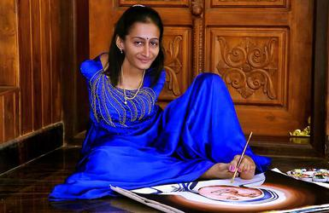

**Key Questions:**

Who was Swapna Augustine and what art work is she famous for?

What is sculpture?

**Key Facts:**

Swapna Augustine was born in Kerala on the 21 January 1975.

She was born without any arms.

A sculpture is an art form made in three dimensions