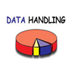

**Curriculum pathway:**

**Key Vocabulary:**

Branching Database - a way of classifying a group of objects.

**Computing Year 3**

**Spring 2**

**Data Handling**

**Key Facts:**

Branching databases are used to classify groups of objects.

**Key Questions:**

What is a branching database?