**Curriculum pathway**

**Key Vocabulary:**

Raising agent - Anything that causes rising within foods, and are usually used in baked goods

Bake - The process of cooking by dry heat, especially in some kind of oven

Yeast - A living single celled organism commonly used in baking

Flour - Finely ground powdery meal of wheat or of any cereal grain or edible seed

Salt - A mineral formed from the two elements sodium and chloride

Leavened - Made light by using yeast or baking powder

Unleavened – Made without baking powder or yeast

Knead - To press something, especially a mixture for making bread, firmly and repeatedly with the hands and fingers

Fermentation – A chemical change that happens in vegetable and animal substances

**DT Year 5**

**Autumn Term – Adventures**

**Bread**

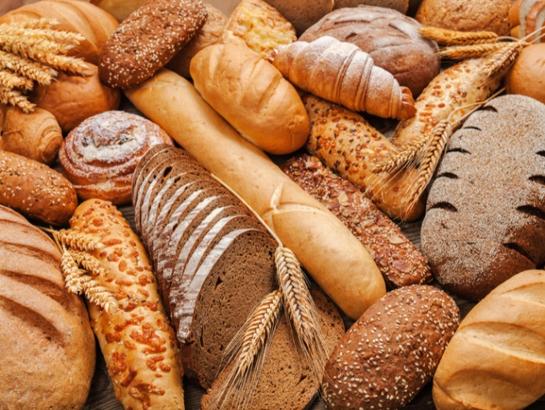

**Key Facts:**

Bread contains: Flour, Water, Salt

Some breads also use a raising agent such as yeast

Ingredients such as seeds, raisins, garlic, herbs etc can be included for taste

Leavened bread contains yeast or another raising agents, examples include:

Brioche, Sourdough, Wholemeal etc.

Unleavened bread doesn’t include a raising agent. Examples include:

Naan, Tortilla, Flatbreads etc.

When making bread, ingredients are mixed together, kneaded and left to rise. They are then baked.

**Key Questions:**

How is bread made?

What are the ingredients?

What makes the dough rise?

Where do different breads come from?