**Curriculum pathway:**

**Key Vocabulary:**

Structure - Anything made up of parts held together in a particular way

Freestanding - A structure that stands on its own without attachment to anything else

Balance - To maintain a controlled position

Secure – To hold parts together

Base - The bottom of something that is its support

Join - To connect, attach

Materials - Any substance that an object is made from

**DT Year 1**

**Summer Term – Incredible India**

**Free standing structure**

**Cooking Indian food**

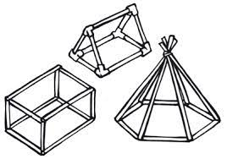

Aspirations

**Key Facts:**

A structure is a building or frame made from more than one part

The taller a structure is the more likely it is to fall over

A wider base makes a structure balance easier

Parts of a structure can be joined in different ways

**Key Questions:**

What is a structure?

What does freestanding mean?

Why do we need structures to be freestanding?

Why is it important for structures to be secure?

How can we make structures stronger, stiffer, more secure?