**Curriculum pathway**

**Key Vocabulary:**

Cushion – A soft pad used to sit, lie or knee on or to lean against

Tie-dye - A hand method of producing patterns in textiles by tying portions of the fabric so that they will not absorb the dye

Pattern - Something that happens or appears in a regular and repeated way

Functional - The way in which something works or operates, or relating to how useful it is

Aesthetic - A set of values relating to nature and the appreciation of beauty

Casing – Strong outer cover to protect things

Stuffing - A soft material (such as cotton or polyester) used to fill cushions

Comfort - A pleasant feeling of being relaxed

Shibori - A Japanese tie-dying technique

Tritik - A method of dyeing cloth

**DT Year 5**

**Summer Term – The Industrial age**

**Combining textiles with art**

**Rock cakes**

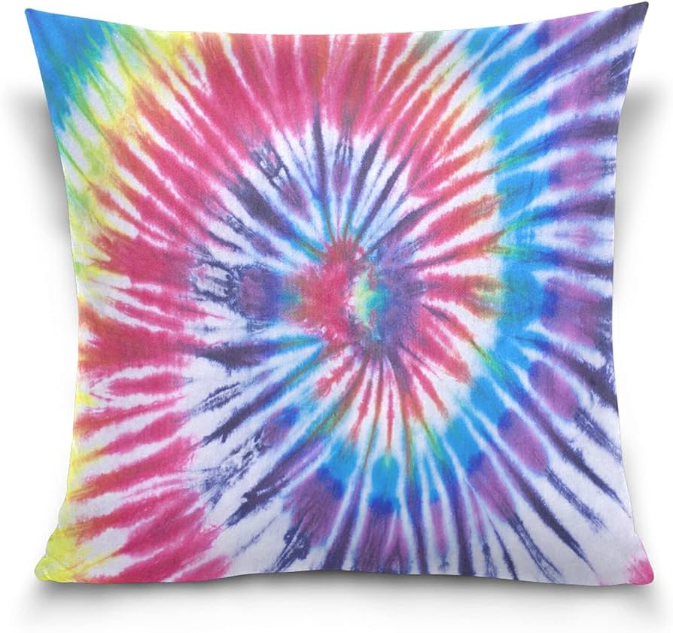

**Key Facts:**

Cushion have a functional use or an aesthetic one (appearance)

Soft materials are used for stuffing to make the cushion comfortable

Tie-dyeing is the process of dyeing fabric by hand in which patterns are created by folding, twisting, crumpling, tying with string before applying the dye to the fabric

Cushion are stitched together and need to be secure to make sure the stuffing remains in place.

**Key Questions:**

Are cushion just for sitting on?

What materials work well for the stuffing of a cushion?

What techniques can be used to add decoration to a cushion?