**Curriculum pathway:**

**Key Vocabulary:**

Wheel - A circular frame with spokes that can rotate

Axle - The rod that goes right through the very centre of the wheel to help it move and stay in place

Windmill – A machine that moves with the power of the wind

Mechanism – A structure of moving parts that performs a function, especially in a machine

Energy - Makes things move

Rotation - When something turns or spins around a point located at its centre

Spin - To turn around and around

**DT Year 2**

**Summer Term – The Great British Seaside**

**Wheels and axles**

**Fruit lollies**

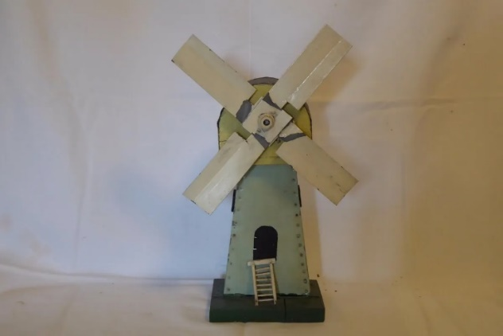

**Key Facts:**

A windmill is a structure with a wheel mechanism that creates energy by being spun around by wind.

A wheel spins around an axle in a rotary motion (round and round).

A windmill has blades that get pushed by wind

**Key Questions:**

What is a wheel?

What is an axle?

What type of motion do they make?

What products/structures use wheel and axle mechanisms?

What are windmills used for?