**Curriculum pathway:**

**Key Vocabulary:**

Fruit - the part of a flowering plant that contains the seeds

Vegetable - the leafy, stem, or root part of a plant that we eat

Kebab – food served on a skewer

Healthy - things that are good for your body

Taste - to tell the difference between flavours in your mouth

Texture - how something feels when it is touched

Safety - being extra careful

Peeling - to remove the skin

Sour - a sharp taste or smell

Bitter – an unpleasant taste or smell

Crunchy - firm and makes a short loud noise when it is eaten

Slimy - thick, wet, and unpleasant

**DT Year 1**

**Spring Term – Eco-warriors**

**Fruit Kebabs**

**Making a healthy meal**

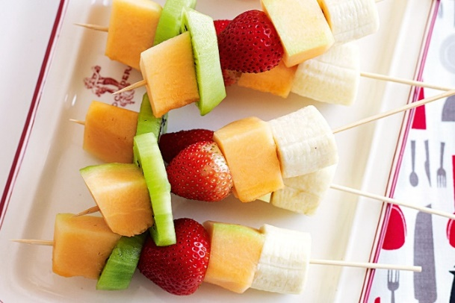

Healthy Lifestyles

**Key Facts:**

A fruit is a food that grows on plants and has a seed.

A vegetable is a food that grows on plants but doesn’t have seeds

Eating healthily supports people to have more energy

Foods have different tastes

Foods have different textures

**Key Questions:**

What are fruit and vegetables?

Why do we need to eat healthily?

What is a kebab?

How can we describe different tastes? (e.g. sweet, sour etc.)

How can we describe different textures? (hard, soft, crunchy etc.)