**Curriculum pathway**

**Key Vocabulary:**

Frame - A basic shape or structure, especially one that outlines or surrounds a door or window

Reinforce - Make stronger

Triangulation – Finding the positions of points in space by measuring the distances, and sometimes angles, between those points and other reference points

Stability – When something is fixed and steady

Temporary - Something that isn't permanent or lasts only a short time

Permanent - Lasting for a limited time

Shell - A hard surface that covers something

Waterproof - Something that keeps water out

Windproof - Not allowing wind to enter or move through

**DT Year 5**

**Spring Term – Beautiful Britain**

**Frame structures**

**Victoria sponge**

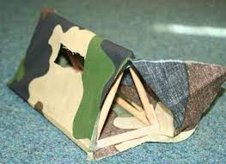

**Key Facts:**

Frame structures are structures that use beams and columns to support an outer shell

Triangular frames are the strongest shape because weight is distributed evenly on the sides and angles

Frame structures are used for power masts, cranes, climbing frames, tents and tipis

**Key Questions:**

What is a frame?

Why do we use frame structures?

What are the advantages of a frame structure?

Are all structures permanent?

What does a shelter have to provide?