**Key Vocabulary:**

Tributary - a stream or river that flows into and joins a main river

Confluence - where two or more flowing bodies of water join together to form a single channel

Meander - a bend in a river

Mouth - the place where a river enters another river, sea, ocean or lake

Erosion - when tiny pieces of the Earth's surface are moved from one place to another

Infiltration - an important process where rain water soaks into the ground, through the soil and underlying rock layers

Run off - occurs when there is more water than land can absorb

Surface - an outside part or layer of something

Source - the start of a river

Absorb - to take in or suck or swallow up

**Curriculum pathway:**

**Geography Year 6**

**Spring Term – Journeys**

**Canals, reservoirs, rivers and the water cycles**

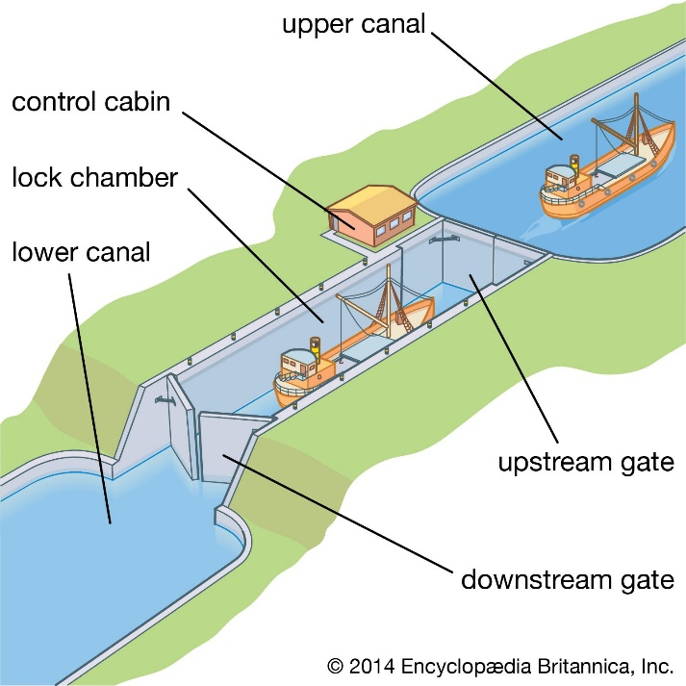

**Key Facts:**

The river Nile is 6,650 km long and runs through 11 countries.

A river is defined as fresh water flowing across the surface of the land usually to the sea.

The biggest river in the UK is the River Severn. It is 330km long.

Rivers are built up of an upper, middle and lower course.

Flooding occurs when there is too much water for the ground to absorb and surface run off overflows the normal river channel.

**Key Questions:**

How do canals go up and down hills?

Where was the first canal?

How can we reduce water pollution?

How many rivers are there in the UK?

Where are the major rivers of the UK located?

Where is the River Nile?

How long is the river Nile?