**Curriculum pathway:**

**Key Vocabulary:**

Trade - The business of buying and selling goods and services

Field work - when you go outside and find out things about a place

Influences - the power to have an important effect on someone or something

Topography - the study of shape and features on the surface of the Earth

Contours - lines drawn on maps that join places of the same height

Human process - A process planned by humans has a purpose. It is a course of action, or a procedure, to achieve a result, or an end-product

Physical process - Processes on Earth that create constant change including movement in the tectonic plates in the crust, wind and water erosion, and deposition

**Geography Year 6**

**Summer Term – Back to our Roots**

**Settlements**

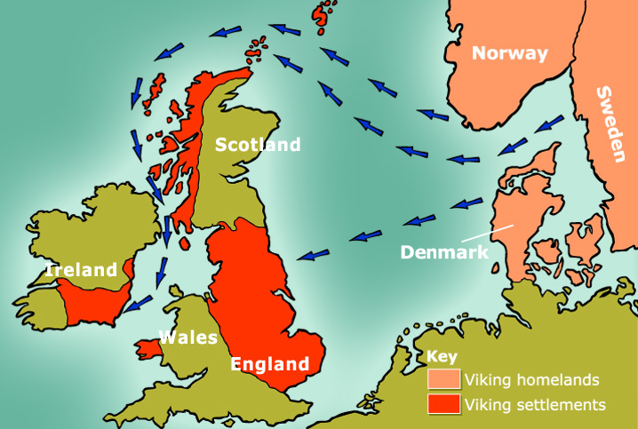

**Key Questions:**

What dictates a places climate?

What is fieldwork?

Where did the Vikings trade?

Which countries did the Vikings visit?

Who invented the 6-figure grid reference?

Which countries did the Vikings come from?

**Key Facts:**

Physical geography is the study of how the earth was shaped and the animals and plants that inhabit it.

Vikings did not use maps. They used the position of the sun and stars to navigate.

A six-figure grid reference indicates 100m2 area on the ground.