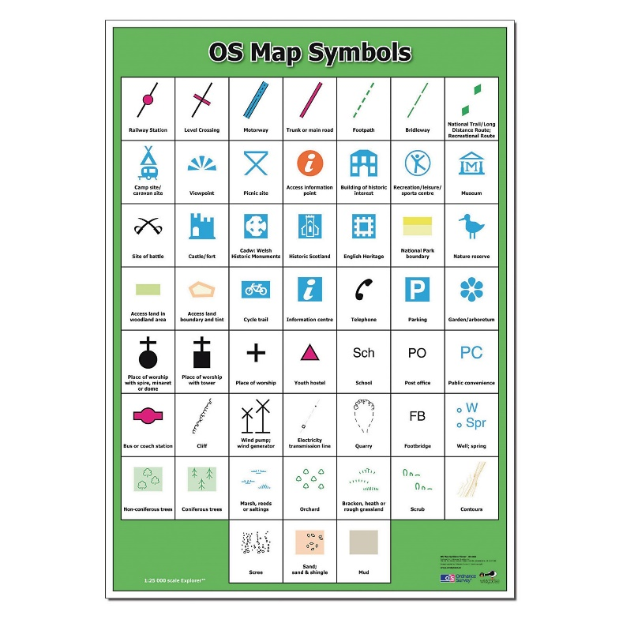

**Curriculum pathway:**

**Geography Year 6**

**Autumn Term – Fighting Fit**

**Grid references and Compass mapping**

**Key Vocabulary:**

Index - a system used to make finding information easier

Ordnance survey - an organisation that creates maps of Great Britain

Relief - the height and steepness of an area

Digital mapping - a method of preparing maps in which the data is stored in a computer for ease of access

**Key Questions:**

Why do we use the symbols on maps that we do?

How do you identify physical features on a map?

What is an Ordnance Survey map?

How many points does a compass have?

What is the difference between four and six figure co-ordinates?

How has Europe changed since 1941?

**Key Facts:**

Ordnance survey has been mapping the UK for over 230 years.

The four categories of human geography are: Culture, economy, politics and government.

During conflicts boundaries of countries change. This can lead to new regions or a creation of a new country.