**Key Vocabulary:**

Volcano – A mountain or hill with an opening

Tectonic plate – Outer most layer of the Earth is called a crust and it is broken into large pieces called tectonic plates

Erupt – To burst open

Magma – Extremely hot liquid and semi-liquid rock under the Earth’s surface

Lava – Magma emerging as liquid onto the Earth’s surface

Crater – A bowl-shape or hollowed out area produced by the impact of volcanic activity.

Vent – To provide an outlet

Conduit – A channel through which liquid is carried

Magma chamber – A large underground pool of liquid rock

**Curriculum pathway:**

**Geography Year 4**

**Summer Term – The Great Escape**

**Volcanoes**

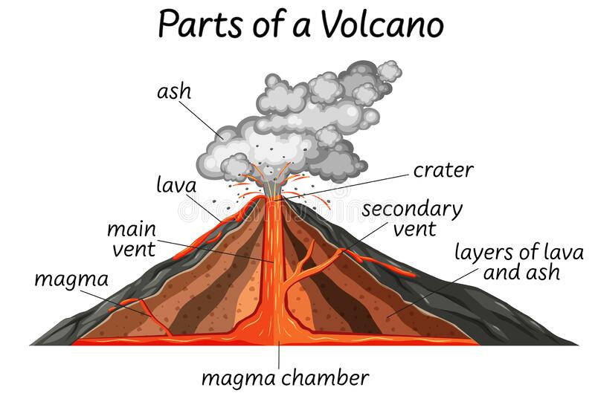

**Key Questions:**

What are the similarities and differences between the United Kingdom and Italy?

How is a volcano formed?

What happens when a volcano erupts?

**Key Facts:**

A volcano is an opening in the Earth's crust that allows magma, hot ash and gases to escape.

Volcanoes can look like mountains or small hills, depending on what type they are.

Hot liquid rock under the Earth’s surface is known as magma, it is called lava after it comes out of a volcano.