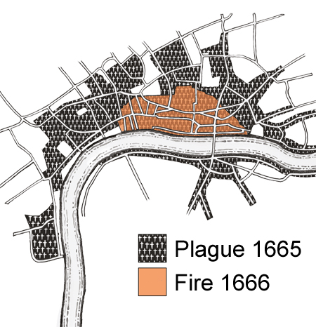

**Key Facts:**

Houses were usually made of timber, wattle and daub.

The upper storeys of some Tudor houses were bigger than the ground floor and would overhang.

The overhang was called a jetty.

The Great Fire of London began in Pudding Lane on the 2nd September 1666

The Great Fire of London eradicated the Great Plague.

After the fire, a law was passed stating that buildings had to stand further apart and be made from brick and stone.

**Curriculum pathway:**

**History Year 4**

**Spring Term – 17th Century Britain**

**The Plague & The Great Fire of London**

**Key Questions:**

What was life like in 17th Century London?

What were the houses made of in the 17th Century?

How are 17th Century houses different to modern houses?

How did the Great Fire of London start?

Why did the fire spread so quickly?

Who was Samuel Pepys?

What changed after the fire?

**Key Vocabulary:**

Timber - wood prepared for use in building and carpentry.

Wattle - a material for making fences, walls, etc., consisting of rods or stakes interlaced with twigs or branches

Daub - plaster, clay, or another substance mixed with straw and applied to laths or wattles to form a wall.

Jetty - a landing stage or small pier at which boats can dock or be moored.

Thatched - cover (a roof or a building) with straw or a similar material

Overhang - a part of something that extends or hangs over something else.

Extinguish – To put out a fire

Fire Hook - a stout pole used in firefighting for tearing down walls or ceilings.

Plague - a contagious bacterial disease

Eradicate – put an end to