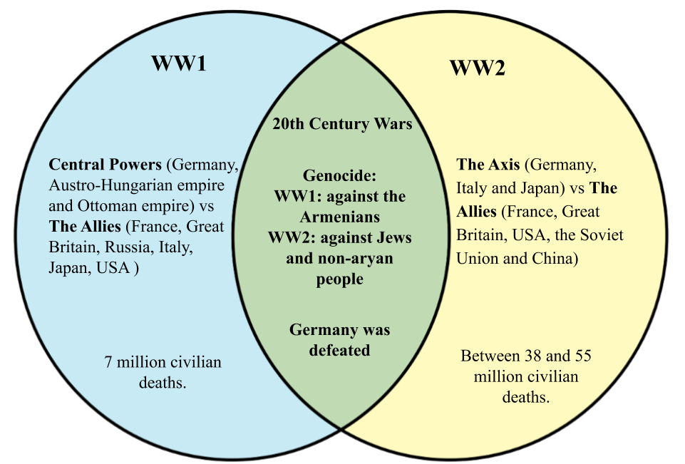

**Curriculum pathway:**

**Key Facts:**

Adolf Hitler used to have people test his food before he ate it as he thought people were trying to poison him.

Over 3.5 million people were evacuated from the biggest cities in the UK during WWII.

Wartime food rationing began in 1940 and lasted until 1954.

During World War II, around 50 million people lost their lives.

VE (Victory in England) Day is celebrated on 8th May each year. This marks the day that Germany surrendered.

**Key Questions:**

How long was WWI? WW2?

Why and how did WWII begin?

Who were Britain's allies during WWII?

Who was the leader of the Nazi party?

What was life like in a WWI trench?

How did animals help in WWI?

What is the purpose of an air raid?

What is propaganda?

What was food rationing?

**Key Vocabulary:**

Nazi - a member of the far-right National Socialist German Workers' Party.

Evacuation - the action of evacuating a person or a place.

Rationing – reducing the amount of supplies available to individuals

Antisemitism - hostility to or prejudice against Jewish people

The Blitz - an intensive or sudden military attack.

1. Anderson shelter - a small air-raid shelter of a type built in the UK during the Second World War.
2. Air raid - an attack in which bombs are dropped from aircraft

Allies – support for a military purpose

Holocaust - destruction or slaughter on a mass scale

Propaganda - information, especially of a biased or misleading nature, used to promote a political cause or point of view.

**History Year 6**

**Autumn Term – Fighting Fit**

**WW1 & WW2**