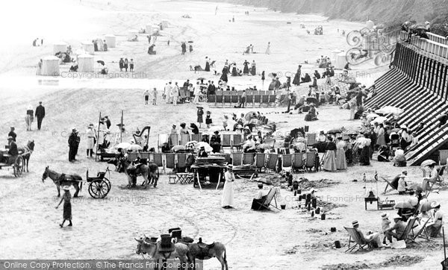

**Key Facts**

As the steam trains became more and more popular, people starting going to the seaside for day trips, weekends and holidays.

Lots of people in the Victorian times, chose to stay fully dressed when they were on the beach.

Activities on the Victorian seaside included eating food, puppets shows, brass bands and jugglers.

People would walk along the promenade, build sandcastles and have picnics.

Filey is a seaside town in the Borough of Scarborough.

Filey was a fishing village and has now become a popular tourist resort.

**Curriculum pathway:**

**History Year 2**

**Summer Term – The Great British Seaside**

**Victorian Seaside**

**Key Vocabulary**

Steam train – Train powered by steam

Carriages – Sections of a train for passengers to sit in

Seaside – A place by the sea

Puppet shows – Theatre shows using puppets

Juggler – An entertainer who tosses and catches object sin the air

Brass Band – A group of musicians playing brass instruments

Promenade – A walkway along the seafront

Fishing village - a village located on the coast whose main local industry is catching fish for food

Resort - a place that is visited for holidays

Tourist Attraction - a place that people visit for pleasure usually while they are on holiday

**Key Questions**

When did seaside holidays become popular?

How did people travel to the seaside?

How does a modern-day seaside holiday compare to a Victorian seaside holiday?

What entertainment did people have at the seaside?

Why did people choose to go to the seaside?

What did Filey look like in the past?

How has Filey changed over time?

What do people still continue to do at the beach?