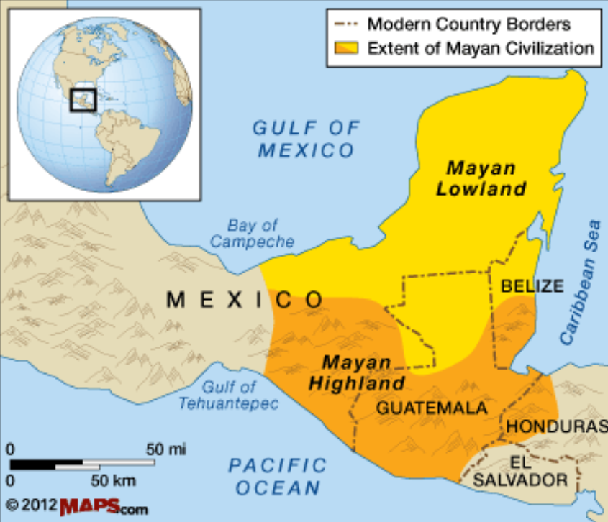

**Curriculum pathway:**

**Key Facts:**

The Maya people developed their own calendars, writing and number systems.

The Maya underworld was called ‘Xibalba’ which means ‘place of fear’.

The Maya invented the concept of ‘zero’.

Headdresses and hats were important. The more important you were, the bigger and the taller your hat would be.

**Key Vocabulary:**

Mesoamerica - the area that is home to the Mesoamerican civilization

Pok-ta-pok - ball game once played by the Aztecs and Maya

Lithography - a process of printing from a flat surface

Hieroglyphs - a stylized picture of an object representing a word, syllable, or sound

Syllabogram - a written symbol representing a single syllable

Logogram - a sign or character representing a word or phrase, such as those used in shorthand and some ancient writing systems

Codex - an ancient manuscript text in book form

1. Cacao - seeds from a small tropical American evergreen tree, from which cocoa, cocoa butter, and chocolate are made.
2. Maize - a Central American cereal plant that yields large grains (corn or sweetcorn).

**History Year 5**

**Autumn Term – Adventures**

**Maya Civilisation**

**Key Questions:**

Who were the Maya people and when and where in the world did they live?

What were the religious beliefs of the Maya people?

How did their number system work?

What are syllabograms and logograms?

What foods were eaten in ancient Maya?

Why was some food particularly significant and precious to the Maya people?