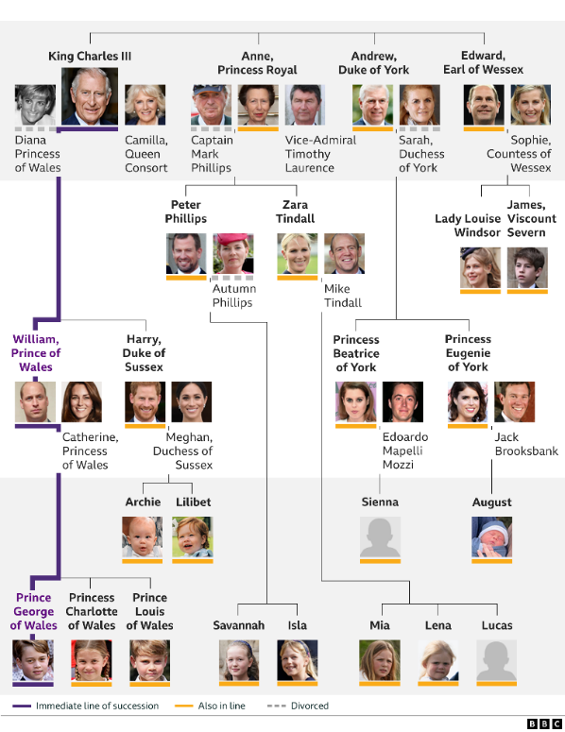

**Key Facts:**

Kings and Queens of England did not have a last name until World War I.

During World War II Queen Elizabeth II worked as a military mechanic

Since 1066 and the Battle of Hastings there have been 41 kings or queens of Great Britain.

Queen Elizabeth II was the longest reigning monarch in British history.

Henry VIII had 6 wives.

**Key Questions:**

How has the role of the monarch of Great Britain changed over time?

How has the population of the UK changed?

Who was the first Monarch in Britain?

Who was the longest reigning Monarch?

Why did King Henry VIII want a male heir?

Who were Henry VIII’s wives, and what did he do to them?

What was it like living in the Tudor times?

What is a family tree?

**Curriculum pathway:**

**Key Vocabulary:**

Monarchy - a state that has a monarch.

Commonwealth - UK together with states that were previously part of the British Empire.

Parliament – those who govern the country

Succession - a number of people or things of a similar kind following one after the other.

Coronation – The ceremony to crown a sovereign

Hereditary – an entitlement passed on through generations

Execution - the carrying out of a sentence of death on a condemned person.

Reign - the period of rule of a monarch

Royal - having the status of a king or queen or a member of their family.

Assassination - to murder a public figure

**History Year 5**

**Spring Term – Beautiful Britain**

**Monarchs**