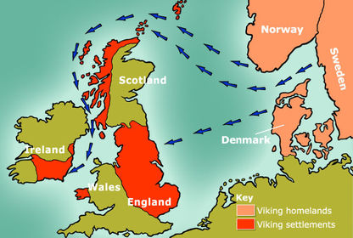

**Curriculum pathway:**

**Key Facts:**

The Vikings were expert boat builders and sailors.

Viking longboats were designed to float high in the water making them easy to land on beaches.

When important Vikings died, they would be placed with all their clothes, jewellery, animals, in a burial ship.

Burial ships would either be covered with a huge mound of earth or set alight and pushed out to sea.

The ‘long houses’ where families lived would have turf roofs to help keep in the heat.

**History Year 6**

**Summer Term – Back to our Roots**

**Vikings & Anglo Saxons**

**Key Vocabulary:**

Saga – a historical word for a story

Runes - a literal alphabet used during the Viking ages,

Longhouse – traditional homes of farming tribes

Danegeld - a tax raised to pay protection money to the Viking raiders to save a land from being ravaged

Danelaw – areas occupied by Danes and other Norsemen.

Anglos - a white English-speaking person of British or northern European origin

Saxons - a member of a people that inhabited parts of central and northern Germany from Roman times

Scots – Scottish people

**Key Questions:**

Where did the Vikings come from and why did they invade Britain?

How did the Vikings change this country?

What were the religious beliefs and practices of the Anglo-Saxon people?

What was the significance of the Anglo-Saxon kings?

Who was King Ethelred?

When and why was Danegeld introduced?

How did the legal system work in Anglo-Saxon Britain?