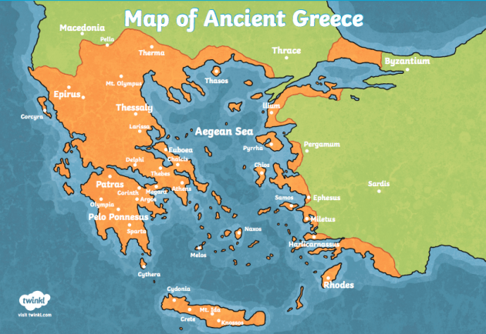

**Curriculum pathway:**

**Key Facts**

The first known democracy was in Ancient Greece.

The Olympic Games began over 2,700 years ago in Olympia.

Every four years, around 50,000 people came from all over the Greece to watch and take part in the Olympic Games.

The Olympic Games were held in honour of Zeus, the king of the gods.

**History Year 3**

**Summer Term – Greeks**

**Ancient Greece**

**Key Questions**

How can we find out about life in Ancient Greece?

What was it like to go to school in Ancient Greece?

What is democracy?

How were the Ancient Greek Olympics different to the modern-day Olympics?

**Key Vocabulary**

Ancient Greece - was a north-eastern [Mediterranean](https://en.wikipedia.org/wiki/Mediterranean_Sea) [civilization](https://en.wikipedia.org/wiki/Civilization), existing from the [Greek Dark Ages](https://en.wikipedia.org/wiki/Greek_Dark_Ages) of the 12th–9th centuries BCE

Athens – The capital city of Greece

Sparta- A main city in Ancient Greece

Temple – a structure which was dedicated to a specific god

Stoa - the great hall in Athens

Democracy - a system where decisions are made by the whole population rather than one central individual.

Olympics – The athletics competition started in Ancient Greece