es feo – it’s ugly

es horrible – it’s horrible

es fabuloso – it’s fabulous

es bonito – it’s nice

se llama – is called

vive en – lives in

medico - doctor

vendedor - seller

vendedora - saleswoman

policía - police

camarero - waiter

camarera - waitress

professor – teacher (male)

profesora – teacher (female)

**Key Vocabulary:**

Presente – present

no está – is not

una cartera – school bag

si toma – if you take

tengo - have

no tengo – don’t have

un pantalón – a pair of trousers

un jersey - jumper

una camisa – a shirt

una falda – a skirt

unos zapatos – a pair of shoes

unos calcetines – a pair of socks

una sudadera – a sweatshirt

una corbata – a tie

**MFL Year 6**

**Autumn Term**

**Clothing revisited, occupations**

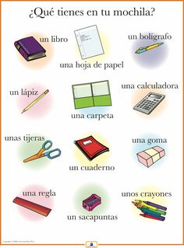

**Key Facts:**

In a negative sentence ‘No’ comes before the verb.

**Things I can already do:**

Write words and phrases using a reference

Look and listen for visual and aural clues in an audio recording

Use short sentences to give a description

Write two or more sentences containing description

Re-order sentences to form a coherent paragraph

Scan a more detailed text with unknown language for details

**Key Questions:**

¿Cómo se ve tu uniforme?

¿quién es de tu familia?