**Key Vocabulary:**

Los números – The numbers

¿Cuántos años tienes? – How old are you?

Tengo…años – I am … old

Es – is

Once - Eleven

Doce - Twelve

Trece - Thirteen

Catorce - Fourteen

Quince – Fifteen

**MFL Year 3**

**Spring Term**

**Numbers to 15, colours**

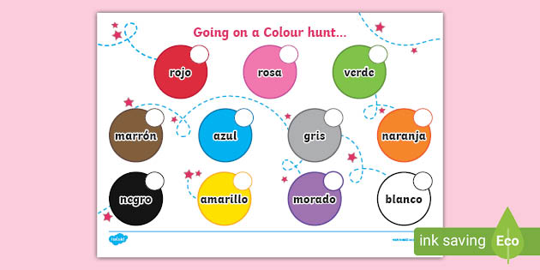

**Key Facts:**

‘qu’ in Spanish is pronounced ‘c’

**Key Questions:**

¿Cuantos anos tienes?

¿Que es?

¿Cual es tu color favorito?

**Things I can already do:**

Make links between some sounds and spellings

Recognise the number of syllables in words

Listen and respond to rhymes

Discriminate between un/una

Listen to and follow commands

Recognise a question form

Perform a simple communicative task