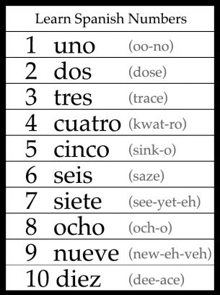
MFL Year 3
Autumn Term
Numbers to 10, Greetings and commands

Things I can already do:
Numbers to 10 in English
The English alphabet and how many letters there are in it
I know the sounds the English letters make

Key Questions:
¿Que tal?

¿Como te llamas?
Key Facts:
‘ll’ in Spanish is pronounced ‘y’

‘j’ in Spanish is pronounced ‘h’

