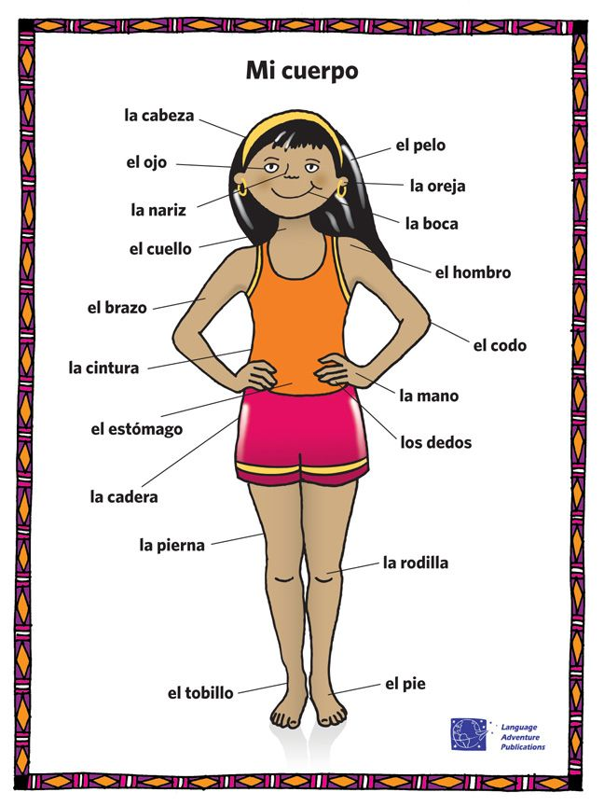

**Key Vocabulary:**

el tigre - Tiger

el hipopótamo – hippopotamus

el cerdo - pig

el león - Lion

el mono - Monkey

el pengüino – penguin

el elefante – elephant

el oso - bear

el ratón - Mouse

la jirafa – giraffe

el cocodrilo – crocodile

**MFL Year 4**

**Autumn Term**

**Body parts, Animals**

unos dientes - teeth

grande - big

pequeño - small

largo - long

tiene - has

gordo - fat

puntiagudo - pointed

también - also

**Key Facts:**

All nouns in Spanish are either masculine or feminine

**Key Questions:**

¿Como se dice…..en espanol?

**Things I can already do:**

Recognise singular and plural items and how they affect the verb

Match phonemes to graphemes

Listen for specific words as they occur in a song

Respond to an extended text by chorusing repeated phrases and vocabulary

Join in reading a story

Match sound to the written word

Listen to a sequence of words and provide the next word in the sequence